**Name:** V Venkata Sri Prasad

**Batch:** Data Engineering

**Date:** 31/01/2024 – (Day 10)

Topics:

1. Get Unique Values from a List in Python
2. Overview of JSON Strings and Files
3. Sort Python lists using key in Python

**Get Unique Values from a List Using Set Method**

Using set() property of Python, we can easily check for the unique values. Insert the values of the list in a set. Set only stores a value once even if it is inserted more than once. After inserting all the values in the set by list_set=set(list1), convert this set to a list to print it.

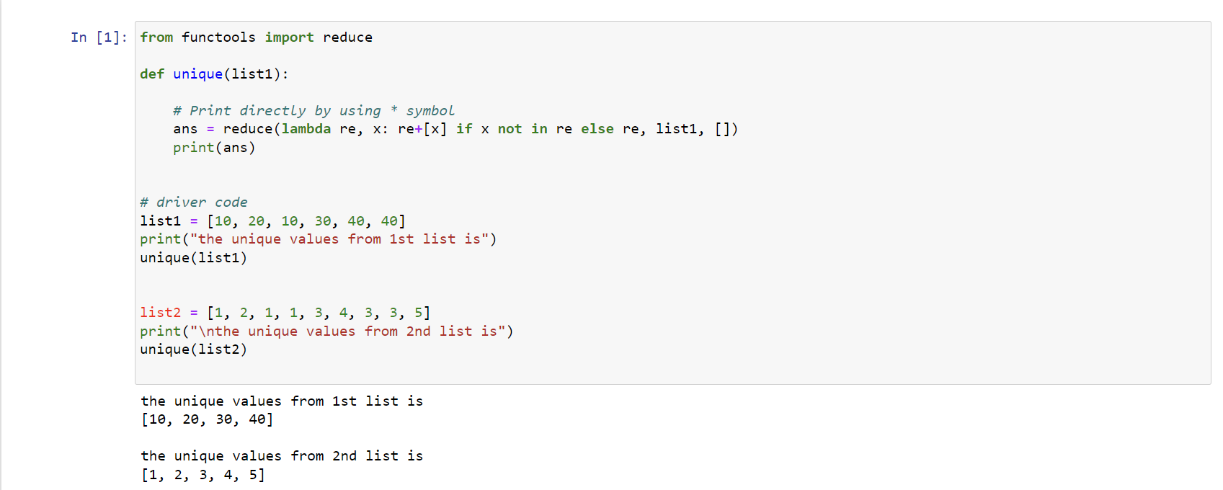

**Get Unique Values From a List in Python Using reduce() function**

Using Python import reduce() from functools and iterate over all element and checks if the element is a duplicate or unique value. Below is the implementation of the above approach.

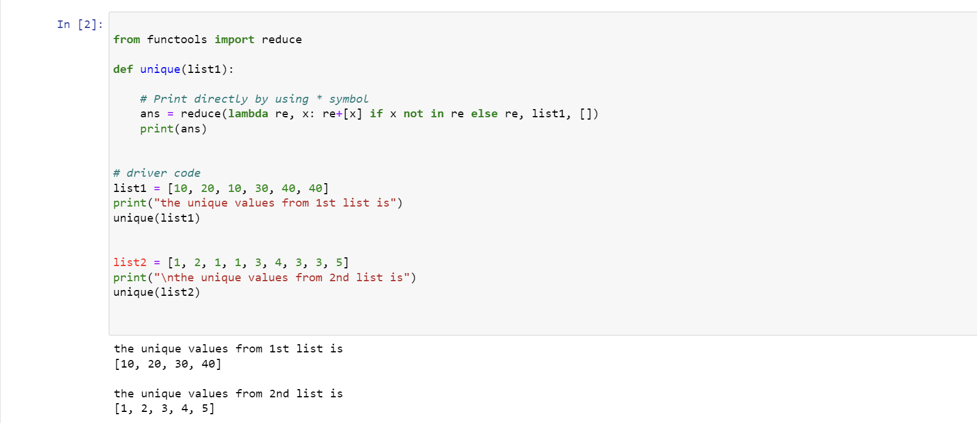

**Get Unique Values From a List in Python Using Operator.countOf() method**

The ‘unique’ function initializes an empty ‘unique_list’, then iterates through ‘list1’. For each element ‘x’, it employs ‘op.countOf()‘ to check if ‘x’ is present in ‘unique_list’. If not found (count is 0), ‘x’ is appended to ‘unique_list’. The final unique values are printed using a loop. The driver code demonstrates this process for two lists, ‘list1’ and ‘list2’, showcasing the extraction of distinct elements from each list while maintaining their original order.

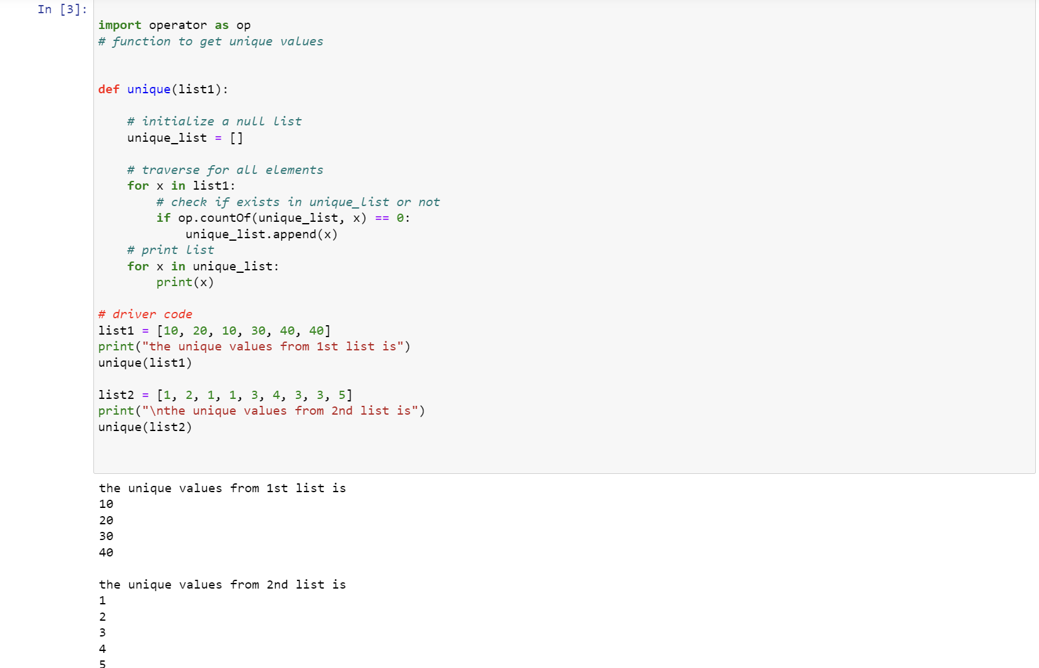

**Get Unique Values From a List in Python Using pandas module**

The ‘unique’ function utilizes Pandas to create a Series from ‘list1’, then employs ‘drop_duplicates()’ to eliminate duplicates and obtain a list of unique values. Subsequently, it iterates through the unique list and prints each element. The driver code demonstrates the process for two lists, ‘list1’ and ‘list2’, providing distinct values for each list.

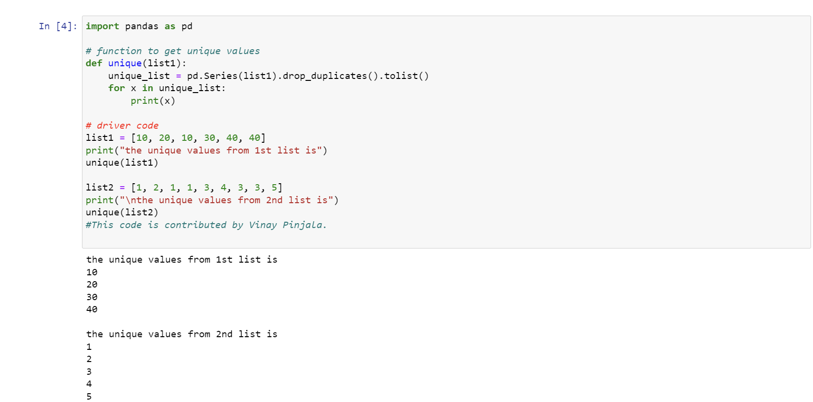

**JSON :**

**JSON** stands for **J**ava**S**cript **O**bject **N**otation. It is a format for structuring data. This format is used by different web applications to communicate with each other.

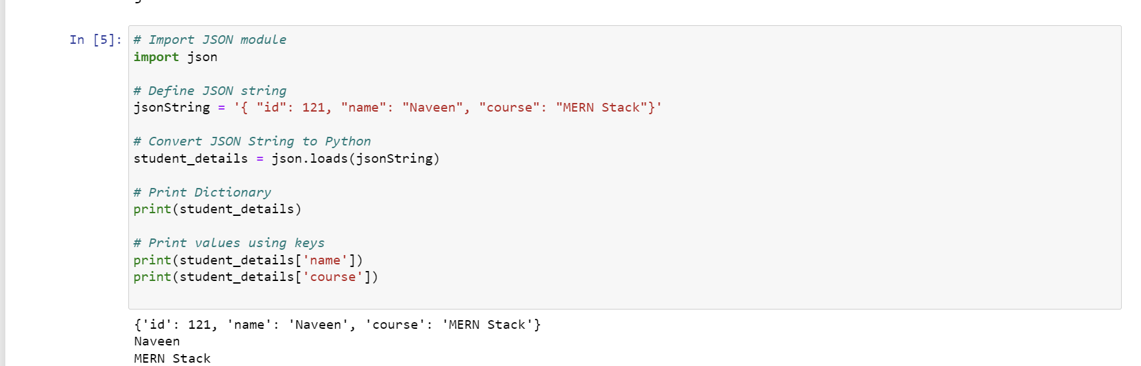

**Convert JSON File to Python Object**

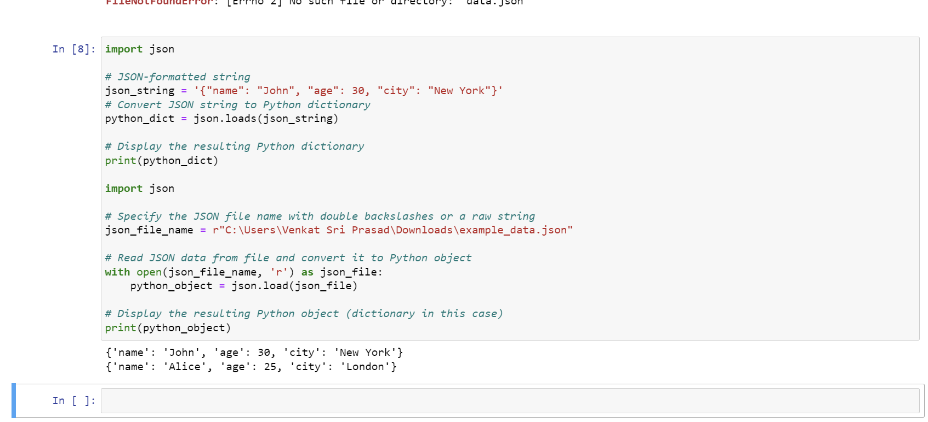

**Convert JSON String to Dictionary in Python**

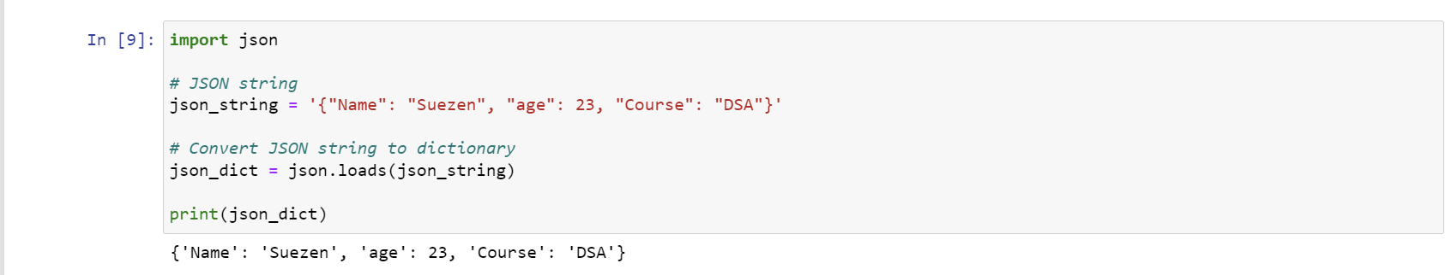

**Convert Nested JSON Object to Dictionary**

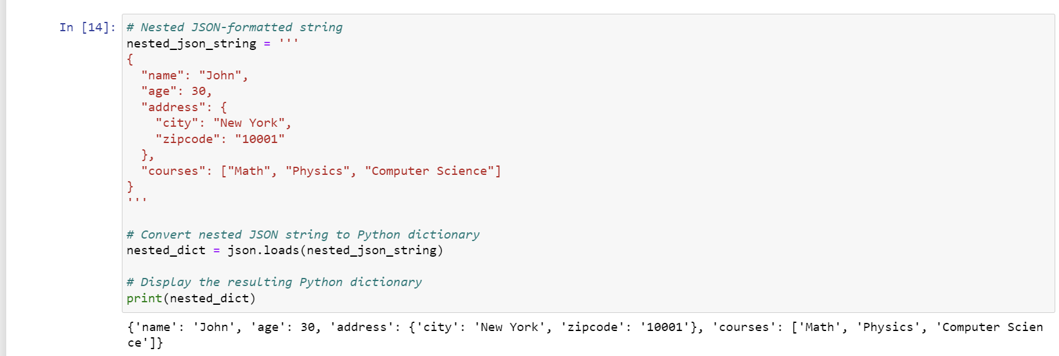

**Read, Write and Parse JSON using Python**

**Python read JSON file**

Let’s suppose we have a JSON file that looks like this.

Here, we have used the open() function to read the JSON file. Then, the file is parsed using json.load() method which gives us a dictionary named data.

1. **Read**

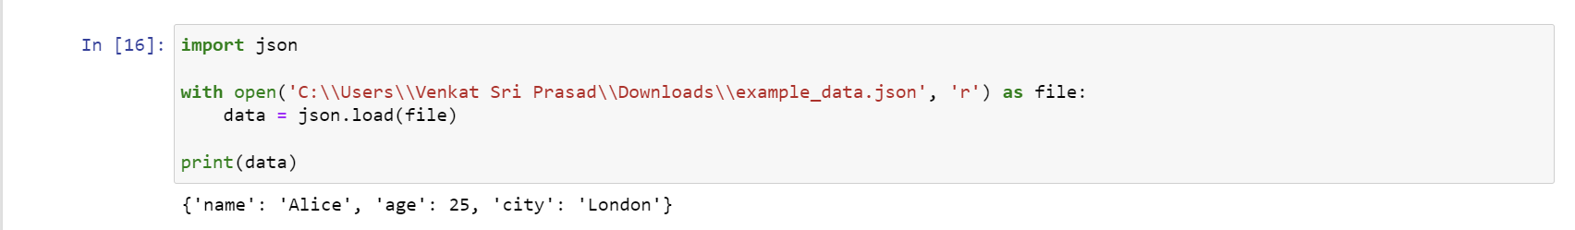

**2.Write**

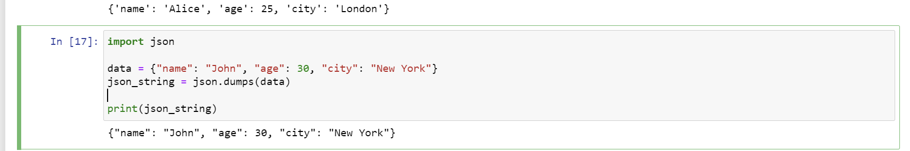

**3. Parsing JSON:**

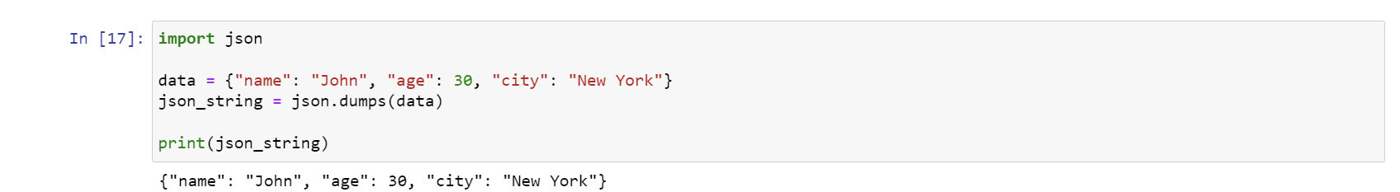

**Sort Python List:**

**sorted(list)**

The easiest way to sort is with the sorted(list) function, which takes a list and returns a new list with those elements in sorted order.

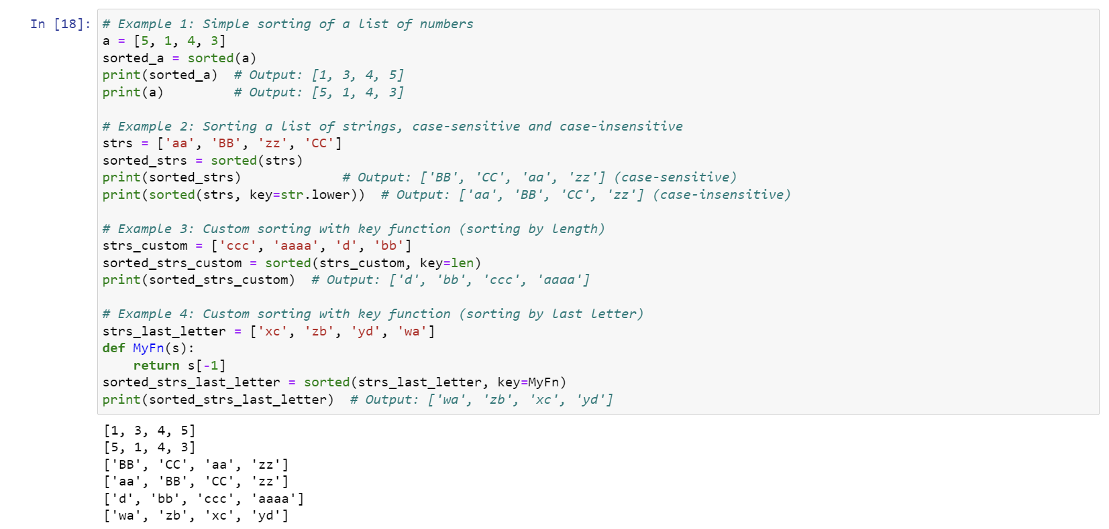

### **sort() method:**

As an alternative to sorted(), the sort() method on a list sorts that list into ascending order, e.g. list.sort(). The sort() method changes the underlying list and returns None

